Topics format

[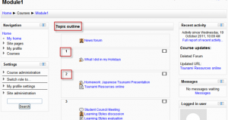](https://docs.moodle.org/31/en/File:Topicoutline.png)

Topic format example

The course is organised into topic sections that a teacher can give titles to. Each topic section consists of activities, resources and labels.

TIP: This is great to use if your course is objective based and each objective may take different amounts of time to complete. An example of this would be scaffolding where the students are building upon the knowledge from earlier topics.

"Show only one section"

With the Weekly, Topics and any contributed format that implements the functionalty, it is possible via *Administration > Course administration > Edit settings* to "show one section per page". Here is a course with eight topics, with the third one currently shown. The links left and right lead to topics two and four:

[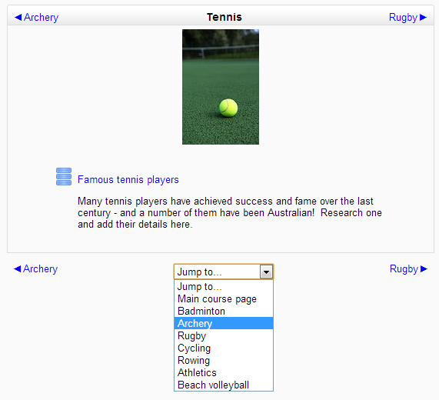](https://docs.moodle.org/31/en/File:Single_section_page.png)

Single section page

*Notes:*

* The course home page shows just the section names and any text in the section description along with activity and resource numbers, with the names being click-able. This is what you see the first time you access the course. Once you have selected a topic by clicking on its name, you then see one section at a time.
* If editing is ON, then the Main course page will display all the content in all the sections.
* There is a 'Jump to...' menu at the bottom of each single section page